Practical 5
Configure IP routing using RIP

Aim: Configure IP routing using Routing Information Protocol (RIP)

Theory:
RIP (Routing Information Protocol) is a standardized Distance Vector protocol, designed for use on smaller networks. RIP was one of the first true Distance Vector routing protocols, and is supported on a wide variety of systems. RIP adheres to the following Distance Vector characteristics:
• RIP sends out periodic routing updates (every 30 seconds)
• RIP sends out the full routing table every periodic update
• RIP uses a form of distance as its metric (in this case, hopcount)
• RIP uses the Bellman-Ford Distance Vector algorithm to determine the best “path” to a particular destination Other characteristics of RIP include:
• RIP supports IP and IPX routing.
• RIP utilizes UDP port 520 • RIP routes have an administrative distance of 120.
• RIP has a maximum hopcount of 15 hops. Any network that is 16 hops away or more is considered unreachable to RIP, thus the maximum diameter of the network is 15 hops. A metric of 16 hops in RIP is considered a poison route or infinity metric.

We study the RIP protocol using the following network

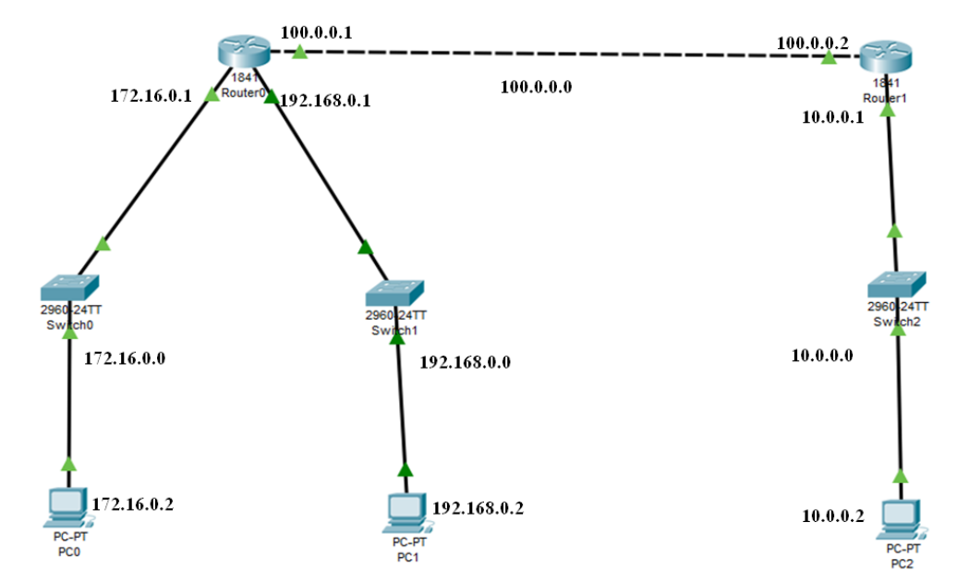

By Default Routers have 2-interfaces in most of the cases, but in our case we need 3-interfacces for Router 0, hence we need to add one interface in Router 0

Now we configure the PC’s and Routers as follows

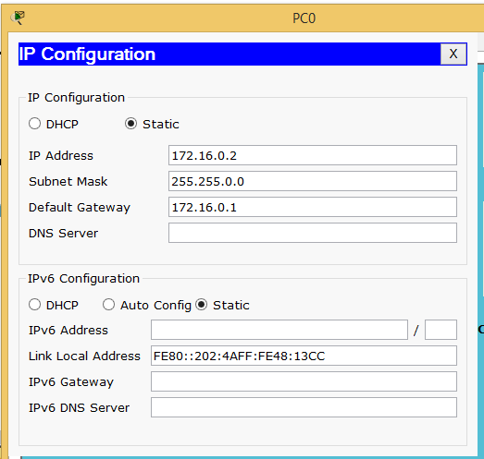
Step 1: Configuring PC0

Step 2: Configuring PC1
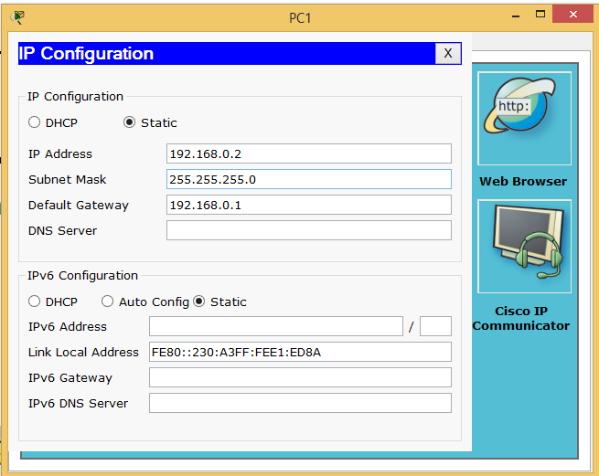

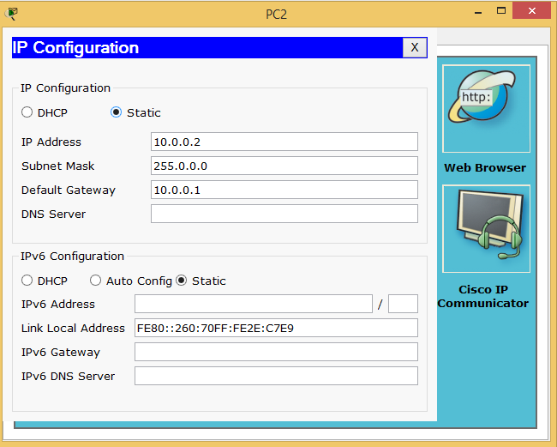
Step 3: Configuring PC0

Step 4: (configure Router 0)
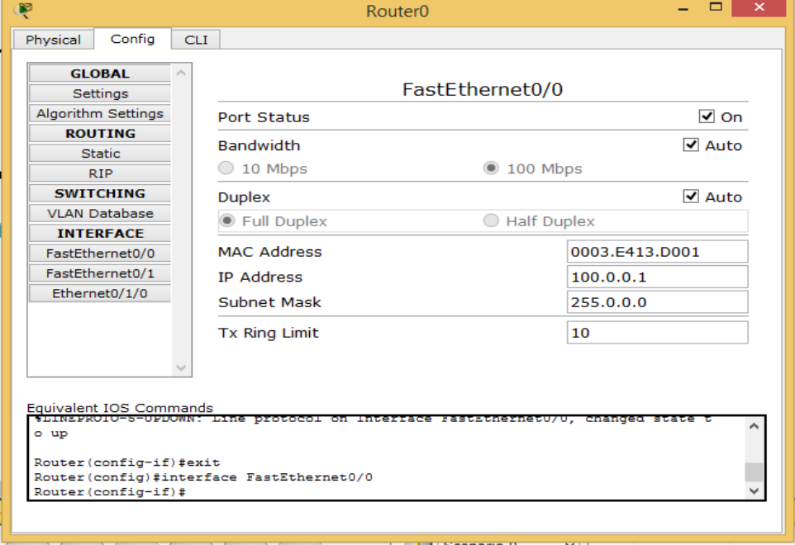

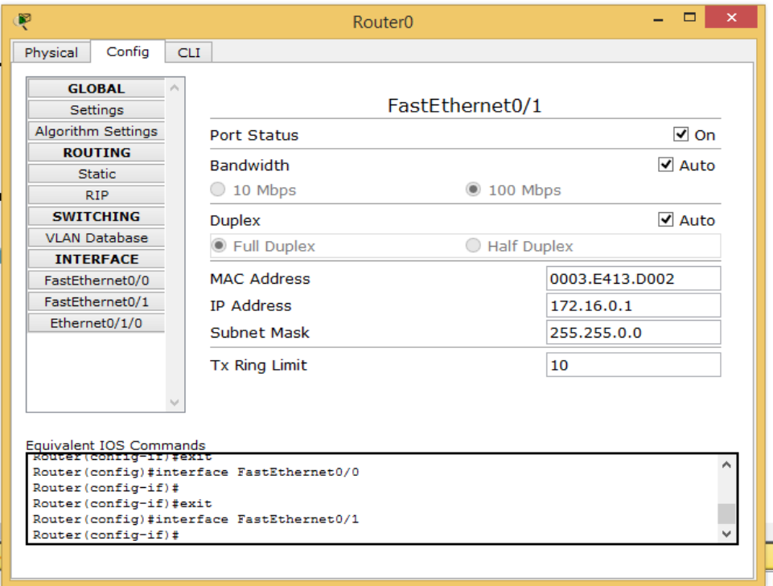
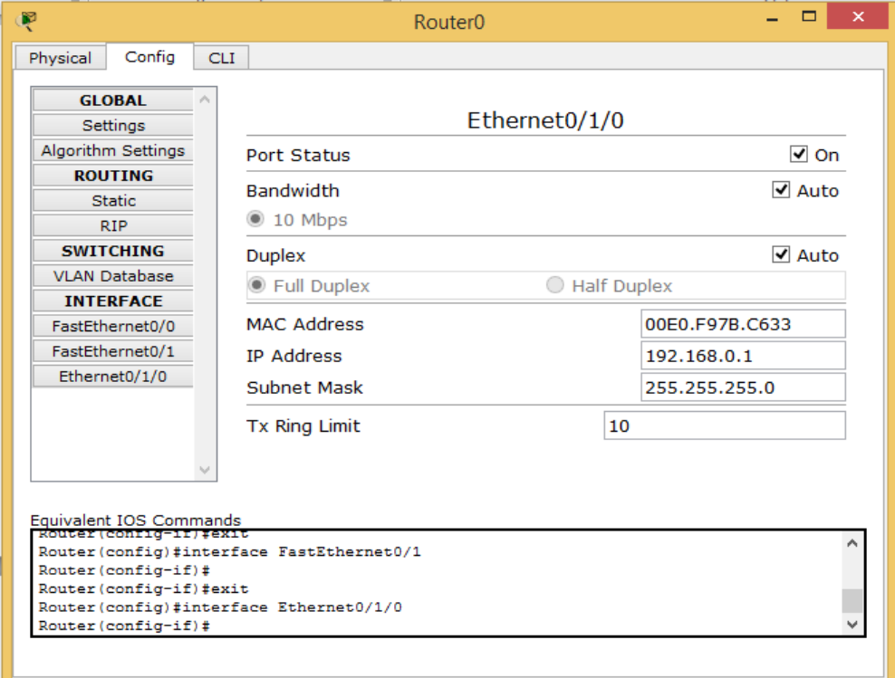
Step 5: (configure Router 1)
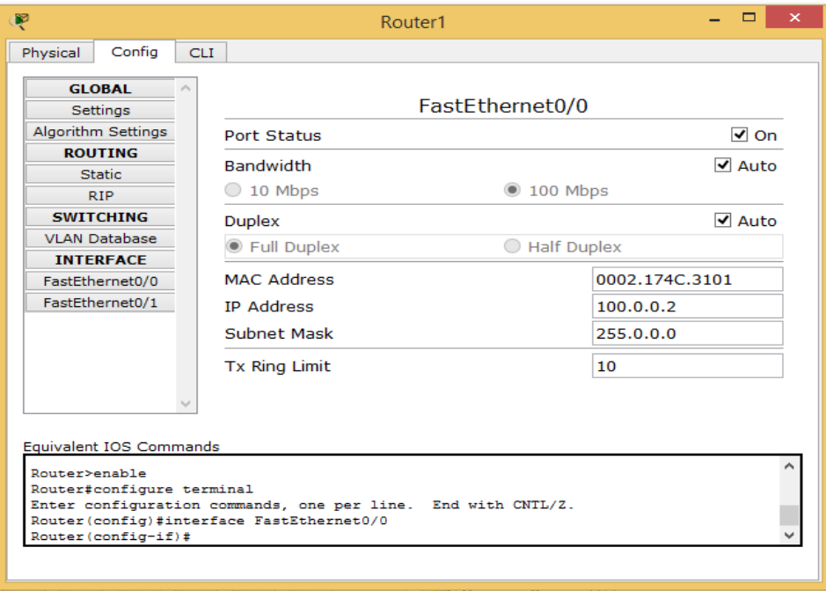
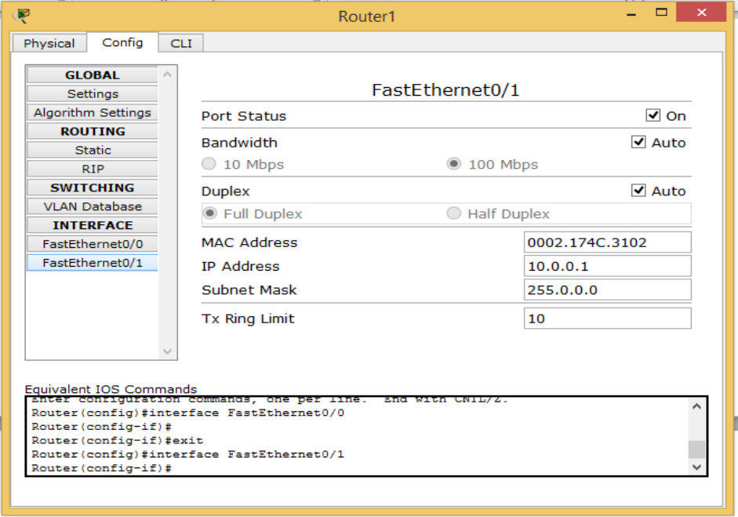

Now we configure the routing table for both the routers
Routing table for Router 0
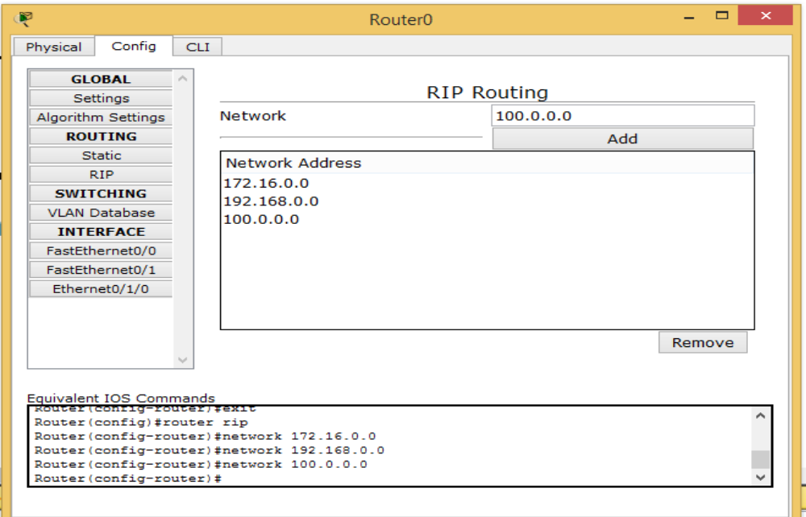

Routing table for Router 1
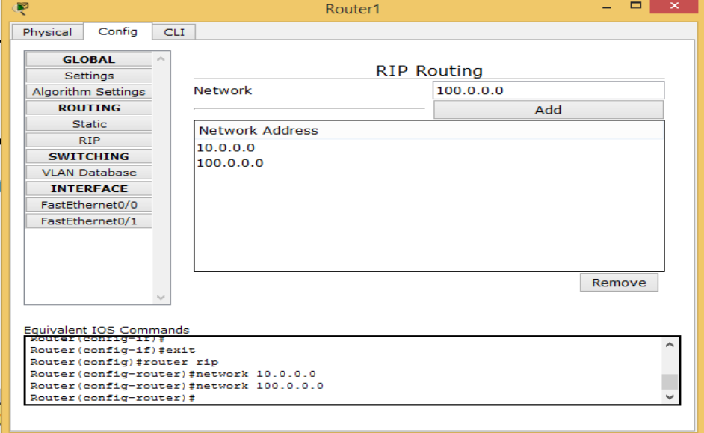

Now we use the ping command to check the working
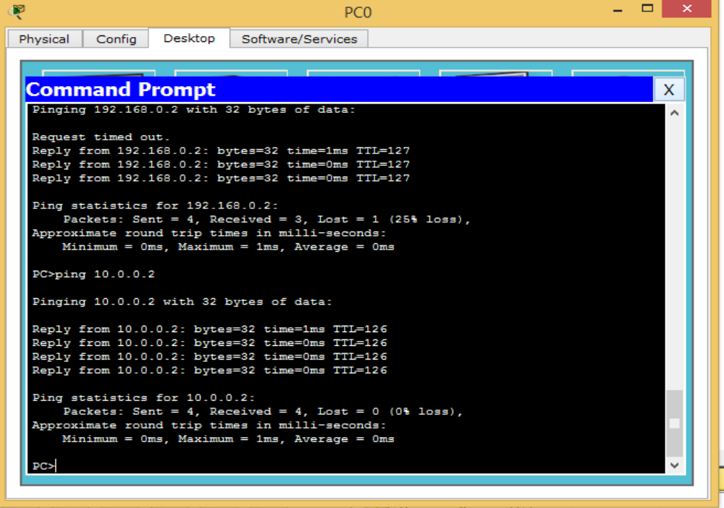

Hence the RIP protocol has been studied

For Video demonstration of the given Practical, scan the QR code | 

